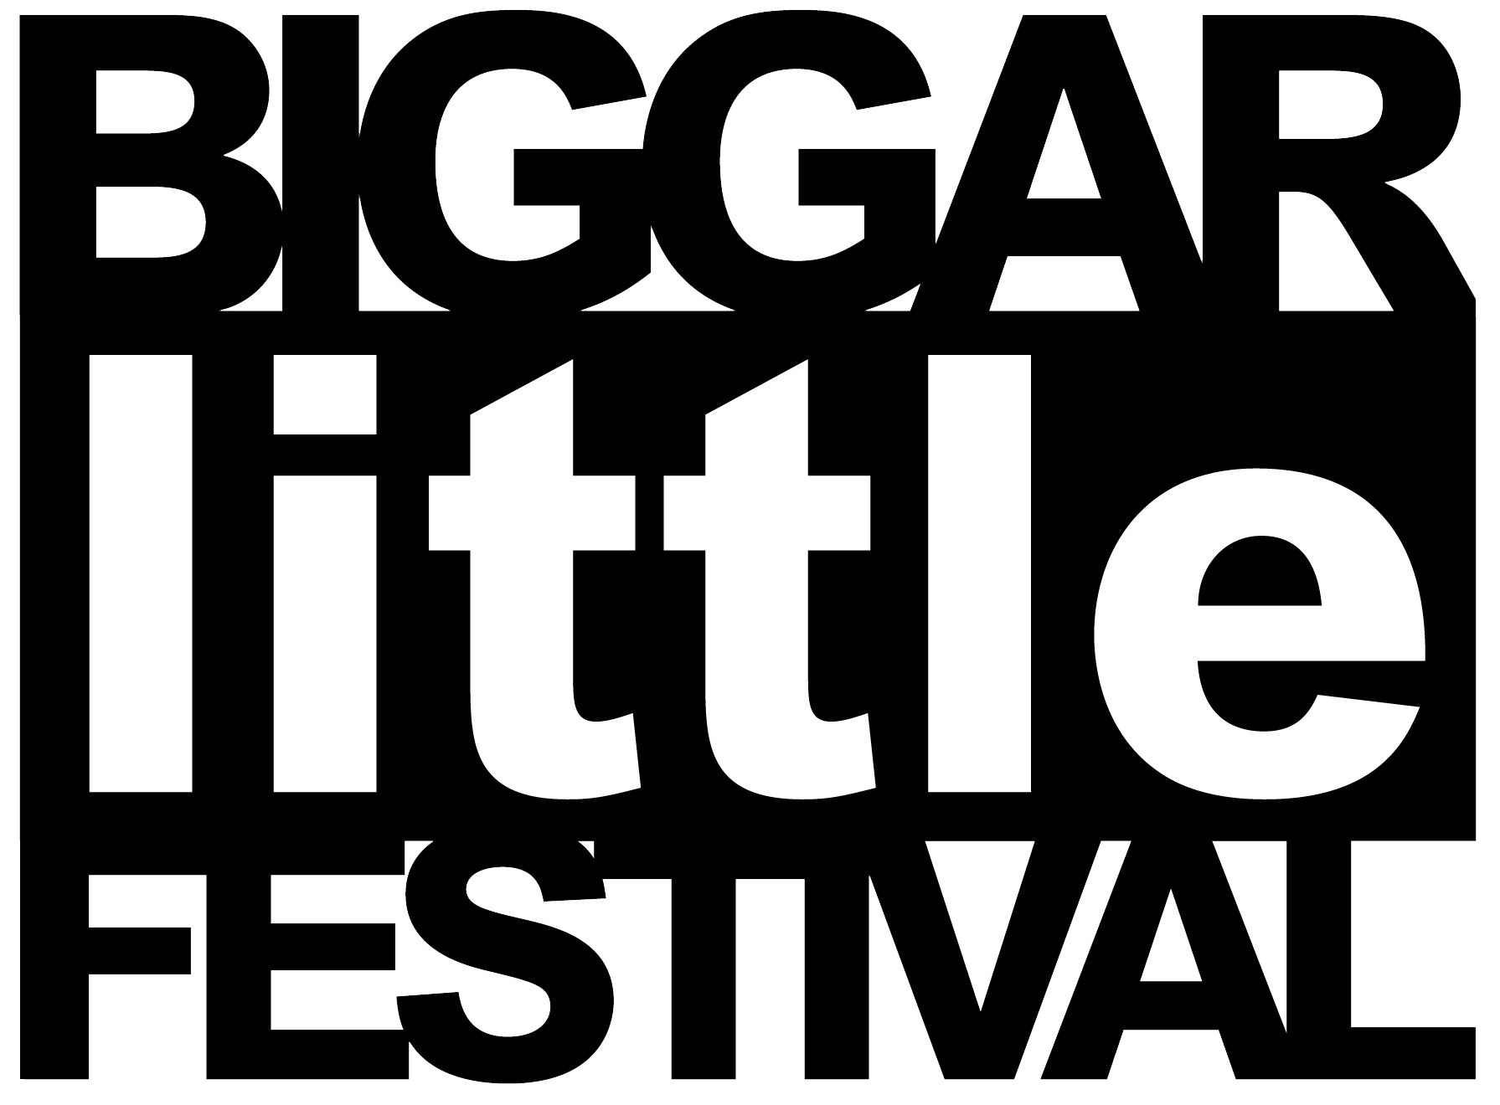
Sponsorship Application

Company Name
Address

Contact Name
Tel Number
e-mail

My company would be pleased to assist Biggar little Festival by taking the marked sponsorship Package
Gold Sponsor | Silver Sponsor | Bronze Sponsor
£500 | £250 | £100

£
My company does not wish to take up a sponsorship package but would like to assist Biggar Little Festival by donating:

Please return your form and donation to:
Mr Alec Taylor
Biggar Little Festival
72 Main St
Symington
Biggar
ML12 6LJ

